Work

- Maintenance & Repair Work For the proper Working of Ro’s has been completed.
- Two new Ro’s Bought in Vidyalaya.
- Transformer present in the Vidyalaya premises has been checked by the Public Health Engineering Department , Deoli.
- All the water inputs and points has been Checked by the PHED , Deoli for the supply of safe drinking water in the vidyalaya .
- Electrical M&R is under process.

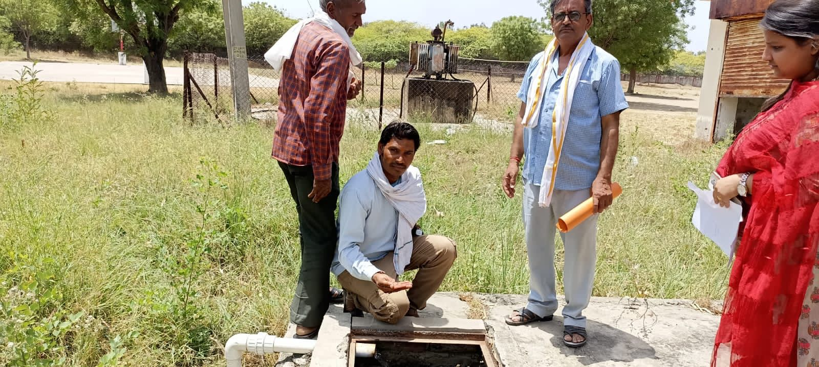
Public Health Engineering Department, Deoli Team Visited Kendriya Vidyalaya Deoli to check the drinking water supply Conditions.
Which is tested Safe to Drink.

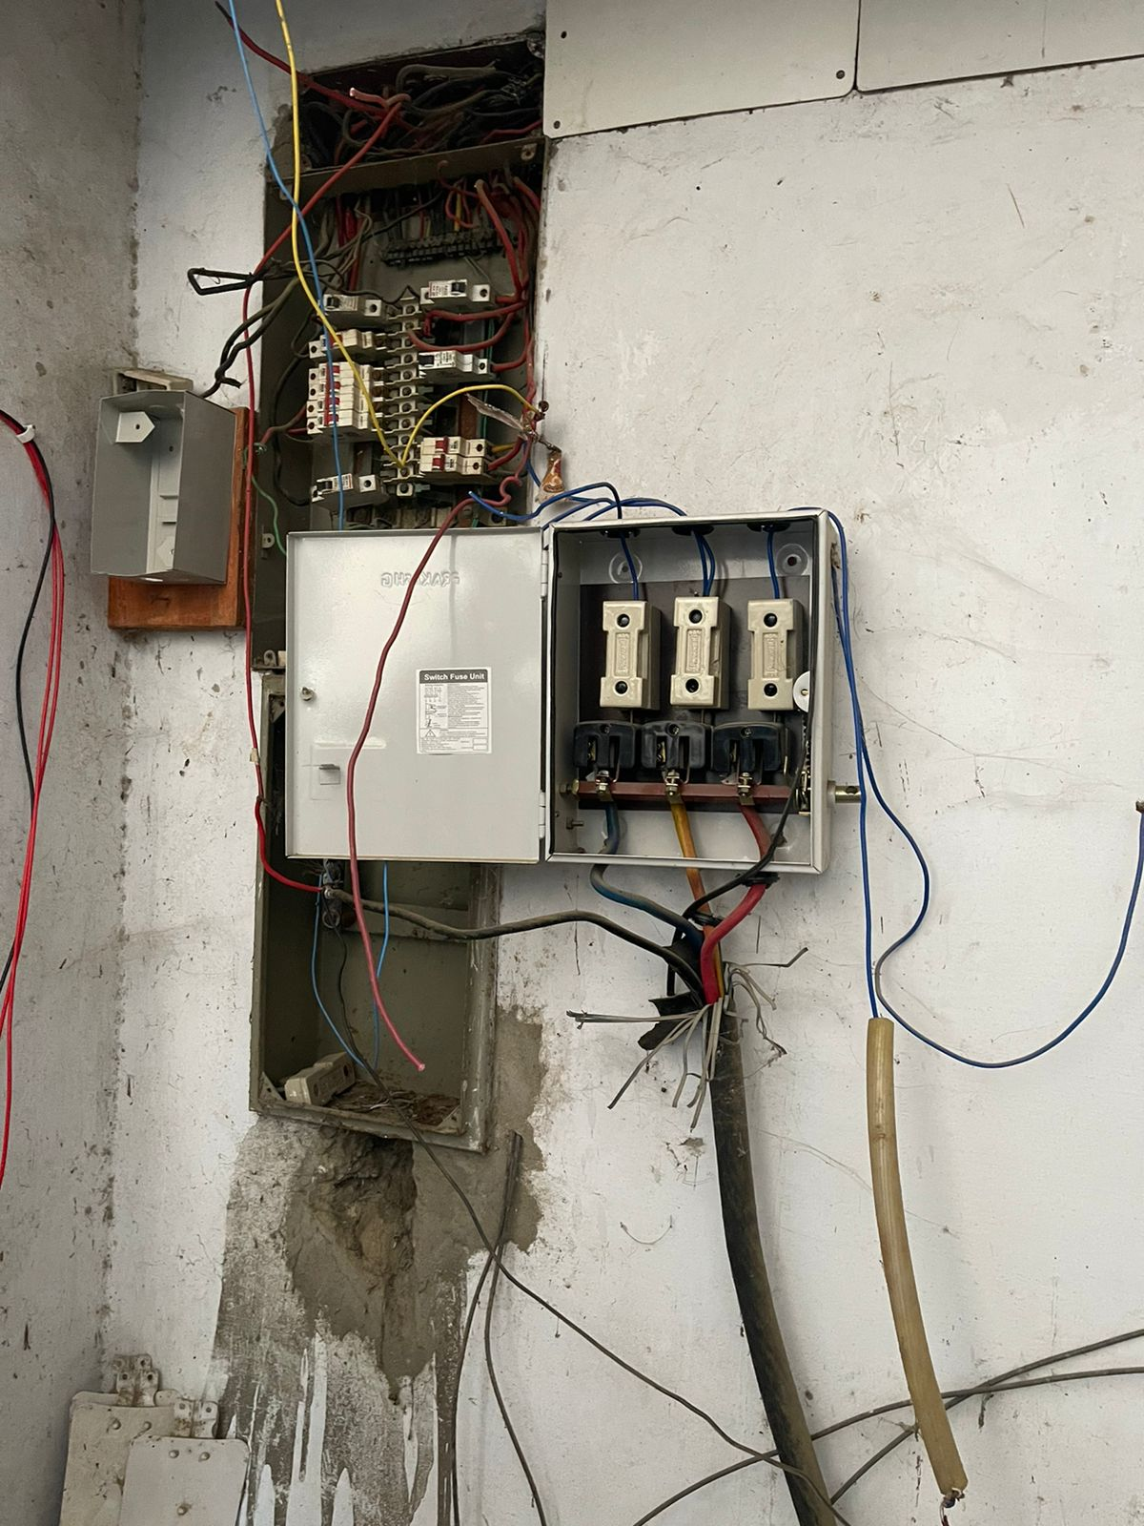
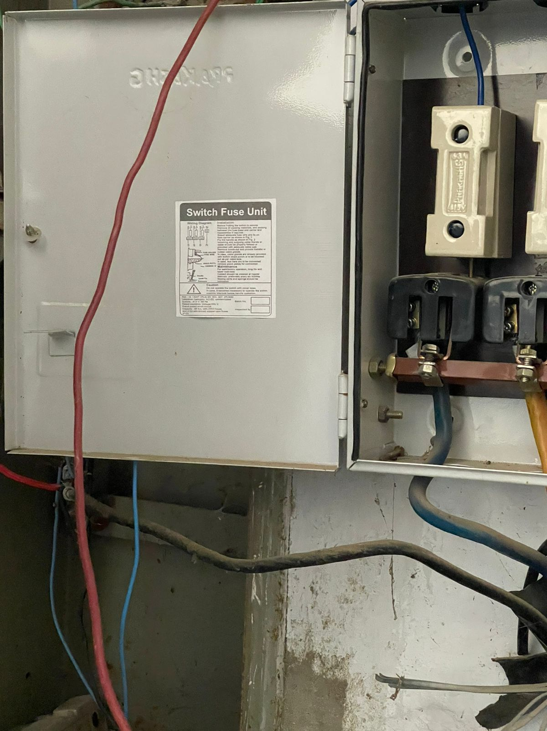
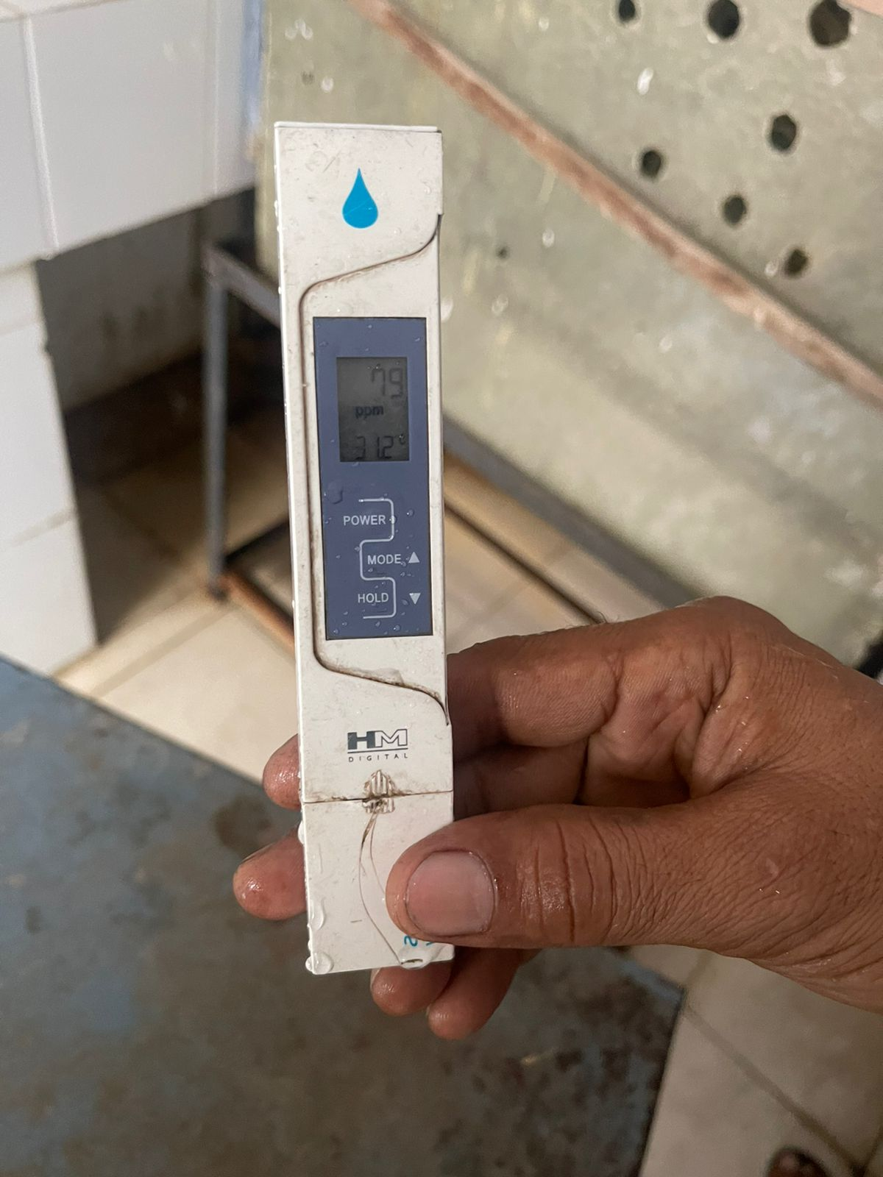
Water TDS Tested and found safe for Drinking.

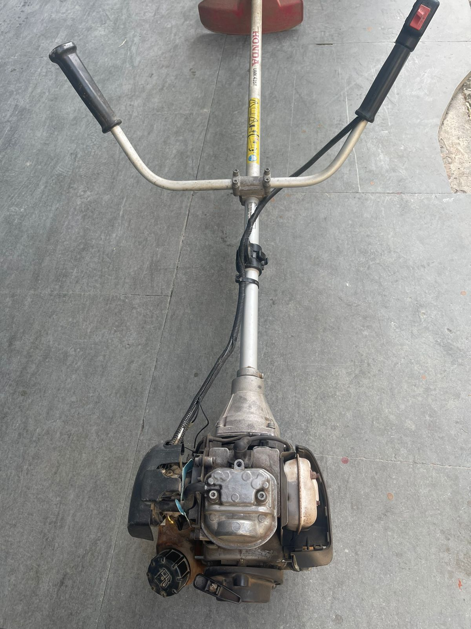
Grass Cutting Machine is being repaired and ready for use
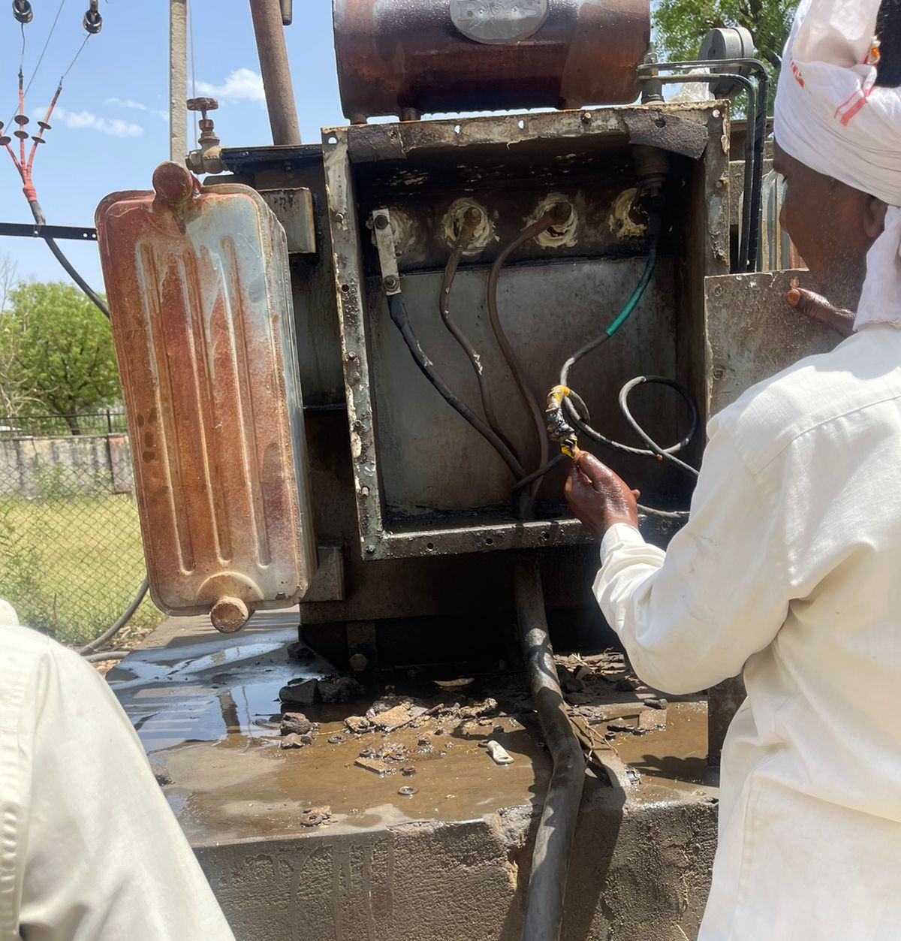
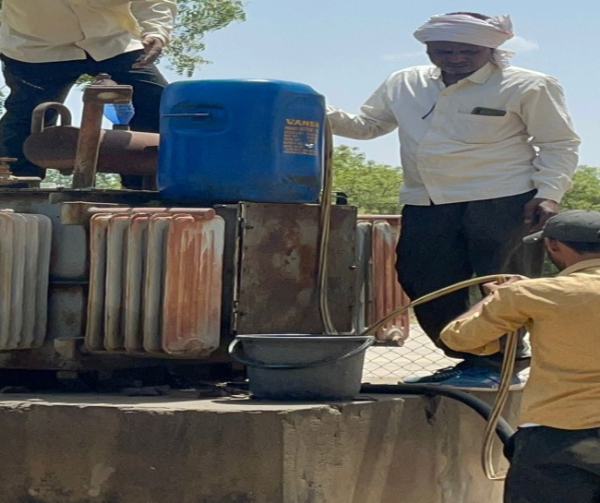
Transformer is checked and tested OK.
Oil is refilled by the Public Health Engineering Department Deoli.

